Designing chilled food display cabinets

The ubiquitous refrigerated display cabinet is an essential part of food retailing. The annual cost of electricity for running a display cabinet, however, can be a large percentage of its initial purchase price. A three year project, AFM 144, has developed methodologies for the design of cabinets to provide longer product shelf life and improved energy efficiency.

The work focused on stand-alone (integral) refrigerated cabinets that are used particularly in small supermarkets and shops, but also in large supermarkets where flexibility in product merchandising is required during special promotions etc. There are many factors that affect the performance of a display cabinet and although current design methods may make use of computer techniques, often they rely heavily on trial and error coupled with experience. This makes it very difficult to optimize a design.

Aims of the project

- Develop models for the main components of the refrigerated display cabinet
- Develop methodologies for modelling refrigerated products in cabinets to allow the prediction of product temperature and dehydration rates and how these are affected by design factors
- Develop simulation tools to help decide the optimum selection of components and design parameters
- Combine the above to form a robust design methodology that optimizes a system design to fulfil user specified requirements at minimum energy and cost.

Cabinet testing

To support the modelling work, a substantial programme of cabinet testing was carried out in an environmental chamber. This also established how well existing cabinet designs performed, particularly in relation to the requirements of the EN 441 test standard. The results were poor. In an ambient of 25°C and 60% RH the best performing cabinet failed to maintain 30% of the test products below its design temperature. This does not necessarily mean that in practice, in a retail store, products will be inadequately chilled as the EN 441 test is quite severe in requiring a continuous, unidirectional flow of air across the front of a cabinet at 0.1-0.2 m/s. The air flow induces a counter current inside the cabinet and warm ambient air flows into the product area. The effect of this is more pronounced in small refrigerated cabinets.

Unwrapped sandwiches, generally baguettes, are popular and tests were done to gauge the effectiveness of increasing humidity on drying rate, shelf-life, and product quality. It was found that relative humidity could be closely controlled in an open cabinet, and the shelf-life extended for a variety of sandwich fillings in baguettes. This work was reinforced by detailed modelling of the moisture and heat transfer processes.

Refrigeration modelling

Various models were developed to describe the operation of a refrigerated cabinet. These take into account the geometry of the cabinet, and its components, e.g. the dimensions, materials and configuration of the evaporator, and link these together to form a compete simulation model of a cabinet. A CFD model is used to describe the air distribution side of the evaporator, including the air curtain. The two main parts of the model are run iteratively to arrive at an optimum design solution.

The model was used with other energy efficiency measures to improve the performance of the original best performing cabinet.
The product temperatures were much improved (cooler and much more uniform temperature distribution in the cabinet.

The energy consumption of the cabinet also reduced from 30.5 kWh/litre/year to 14.6 kWh/litre/year. This is the total energy used by the cabinet per litre of chilled usable space. It was estimated that the cost of the improvements could be repaid within a year of operation.

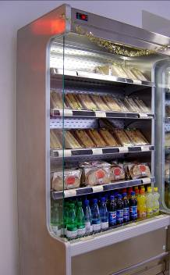

Vertical multi-deck cabinet

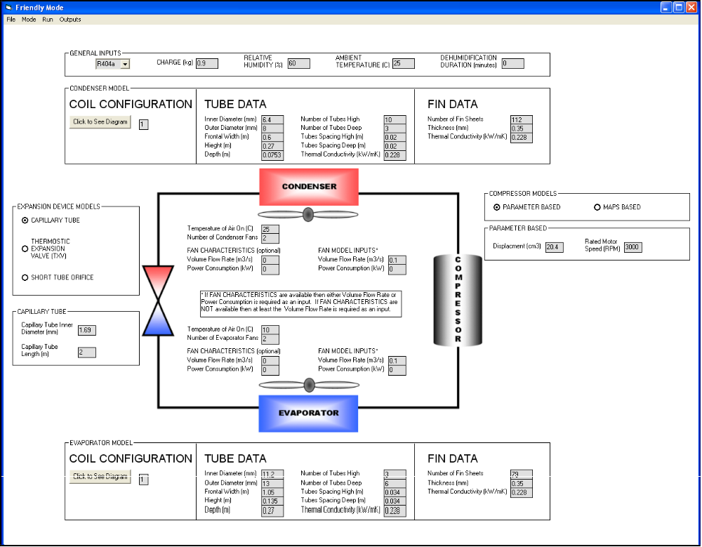
Benefits
Screen image of user interface of the refrigeration system model

The methodology for improving the design of refrigerated cabinets has already been used by one of the project partners and is currently being developed for future commercialization. Given the large amount of energy being used in

refrigeration, there is great potential to reduce both the operating costs to
store owners and the associated environmental impact. The high and increasing real cost of electricity will also make what is already a sound economic case for specifying efficient display cabinets even more persuasive.

Project partners

The project was funded by the Defra LINK scheme with the following partners: Brunel University, Greggs Plc, Bond Retail Services Ltd and Doug Marriott Associates.

FURTHER INFORMATION AFM 144
Professor Savvas Tassou
School of Engineering & Design,
Brunel University,
UXBRIDGE,
Middlesex,
UB8 3PG
Tel: 01895 26 6866
E-mail: Savvas.Tassou@brunel.ac.uk

